Healthcare Analytics & Intelligence Platform
Week 2 Report
Analytics & Machine Learning
From a clean data foundation to working analytics, forecasting, and risk prediction
Author: Suru
Repository: Sooryasooru/CAPSTONE-HEALTHCARE-PROJECT

Contents

1. Executive summary
Week 2 turned the data foundation built in Week 1 into working intelligence. On top of the medallion PostgreSQL database, three capabilities were delivered: an analytics layer that surfaces population health metrics through an interactive dashboard; an operational forecasting model that projects future hospital admissions for planning; and a multi-risk patient classifier that scores mortality, kidney-injury, and heart-failure risk.
The work was guided by one principle carried over from Week 1 — honesty about what the data can and cannot support. That principle produced the most valuable outcomes of the week: a forecasting evaluation scoped truthfully to a short series, and the detection and correction of two data-leakage problems in the risk models. The result is a set of components that are not only functional but defensible.

2. From Week 1 to Week 2 — the connection
Week 2 did not start from scratch. Every component consumes something Week 1 produced. Understanding that hand-off is the key to understanding the project as one connected system rather than a collection of parts.

2.1 What Week 1 delivered
Week 1 built the data foundation: six independent healthcare data sources ingested through an ETL pipeline into a PostgreSQL database organised in three medallion layers — Bronze (raw), Silver (cleaned and typed), and Gold (analytics-ready views). It also produced an exploratory analysis (EDA) that established several principles about the data.

2.2 How the foundation feeds Week 2
The three layers serve different Week 2 consumers, and the split is deliberate:
- The Gold analytics views feed the analytics engine and dashboard. They already aggregate population metrics, so the analytics layer reads finished summaries rather than re-computing them.
- The Silver patients table feeds the prediction models. A model needs the individual feature values for each patient (age, labs, comorbidities), which the per-row Silver layer provides — a Gold aggregate would have collapsed exactly the detail the model learns from.
- The EDA findings shaped the modelling decisions directly (see 2.3).
This is the platform's core design: a one-way flow where the database is the foundation, analytics and prediction are consumers that read from different layers, and the dashboard presents what they produce.

2.3 EDA findings that shaped the models
Week 1 EDA finding | How it shaped Week 2
Missingness is informative (e.g. BNP missing = test not ordered) | Features encode a missingness flag for each lab before filling, so the model can use “test not ordered” as a signal rather than discarding it.
Outliers are real critical patients | Outliers were kept, not removed; tree models (Random Forest, XGBoost) were chosen partly because they are robust to them.
Datasets are independent domains | Models are trained per domain; the dashboard labels each section by its source rather than implying one unified cohort.
Patients data is cardiac | Risk prediction is scoped to cardiac / kidney / mortality risks — stated explicitly rather than overclaimed.

3. System architecture
The whole platform follows a single one-way data flow. Raw sources are refined through the database layers; analytics and prediction both read from the database but answer different questions; the dashboard presents the results. No module reaches backwards, which keeps the system maintainable.
Analytics answers population-level questions (“what is happening across patients?”) and reads the Gold serving layer. Prediction answers questions about quantities and individuals (“what will happen next, and to whom?”) and reads the Silver layer. The two modules are shown in detail in Sections 4 and 5.

4. The analytics layer
The analytics layer converts the Gold views into named, meaningful outputs and presents them. It is built in three tiers, each consuming the one below.

4.1 Analytics engine
The engine wraps each Gold view in a Python function that runs the query and returns a clean table. The dashboard and KPI layer call these functions by name and never touch SQL or the database connection directly — a clean boundary that means a query can change in one place without breaking anything downstream.

4.2 Healthcare KPIs
The KPI layer turns raw engine output into five named clinical metrics, each self-describing (value, label, unit): mortality rate, discharge-against-medical-advice (DAMA) rate, ICU sepsis rate, 30-day ICU readmission rate, and average comorbidity burden. These are standard hospital quality measures, so the platform reports metrics that real institutions track. The layer was verified with an automated test suite (six passing tests).

4.3 The dashboard
The dashboard is the presentation layer — it computes nothing new, only displays what the analytics engine and KPI layer produce. It shows KPI cards, two fixed overview charts (cardiac admission outcomes and comorbidity prevalence), and an interactive drill-down panel driven by a dropdown, each view accompanied by a short clinical interpretation. A clinical colour palette is used deliberately: red is reserved for mortality and critical severity, so colour itself carries meaning.
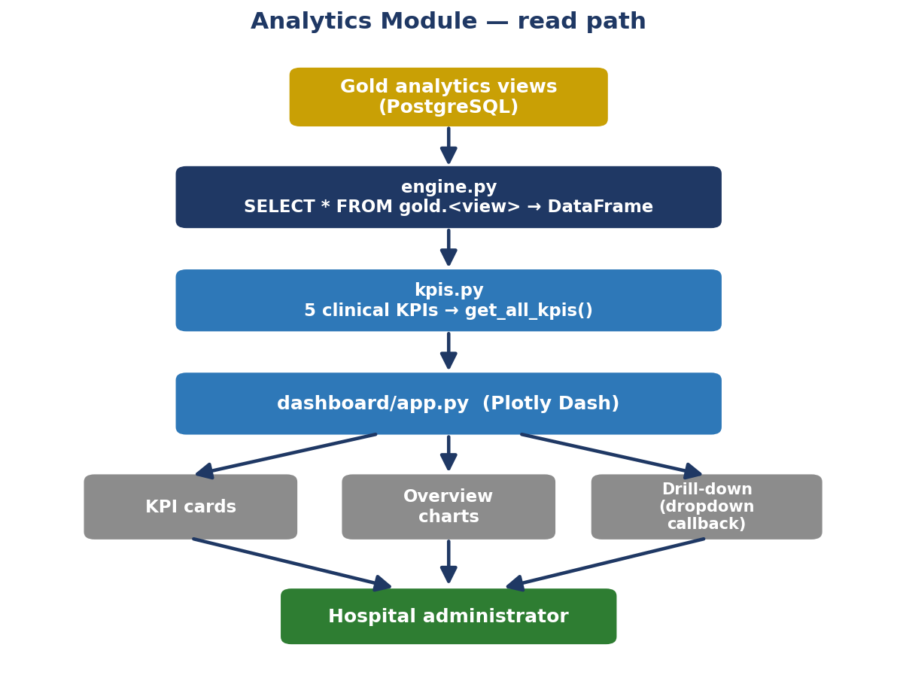
Figure 1 — Analytics module: the read path from Gold views through the engine and KPIs to the dashboard.

5. The prediction layer
The prediction layer contains two distinct capabilities. They answer different questions, use different algorithms, and are evaluated with different metrics — a distinction the report returns to because it drives every modelling choice.
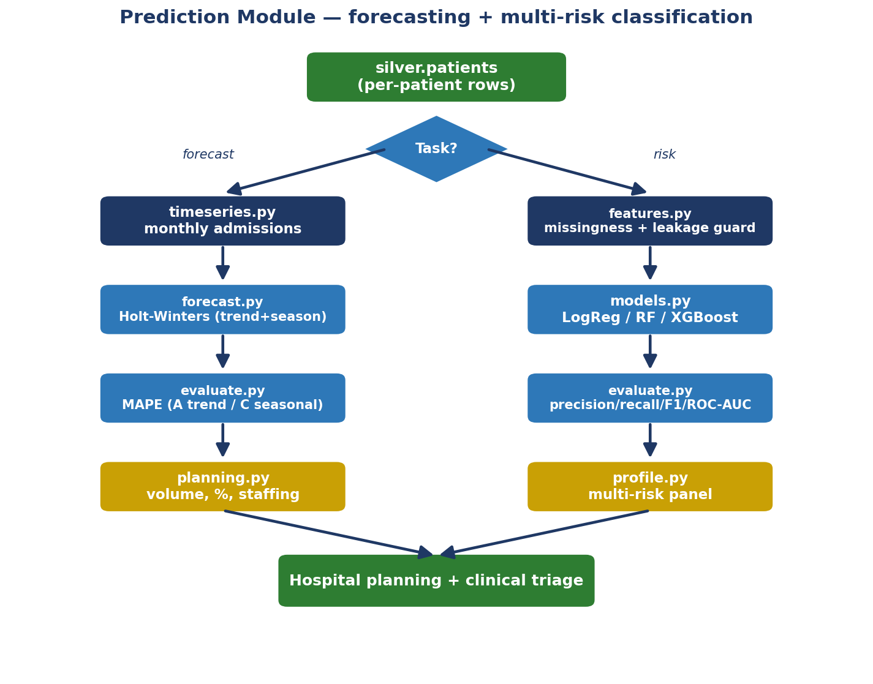
Figure 2 — Prediction module: the Silver patient table branches into forecasting (left) and multi-risk classification (right).

5.1 Operational forecasting
The forecasting capability projects future monthly hospital admissions so administrators can plan staffing and resources. It was built in four steps.
- Build the monthly series. The patient table's month label is parsed into proper dates and aggregated into a clean, chronologically-ordered series of 24 months (April 2017 to March 2019).
- Forecast. A Holt-Winters (Exponential Smoothing) model learns the series' level, upward trend, and yearly seasonal cycle, then projects forward. The data shows clear year-over-year growth and a winter peak, both of which the model captures.
- Evaluate honestly (see Section 6).
- Translate to planning. The forecast is converted into operational figures: projected volume, percentage change versus the last month, projected cardiac cases (using the real CAD prevalence), and an illustrative nursing estimate based on a clearly-stated staffing ratio.
The forecasting model and its planning translation turn a statistical projection into the language hospital administrators use: “next month, expect this many admissions, mostly cardiac, so plan this much capacity.”

5.2 Multi-risk patient classification
The classifier produces a risk panel for an individual patient — mortality, acute kidney injury (AKI), and heart-failure risk scored together — rather than predicting a single isolated outcome. It is an early-warning triage aid, not a diagnosis, and because the data is cardiac, the risks are scoped accordingly.
One shared feature matrix (age, labs, comorbidities, with missingness encoded as signal) feeds three candidate models per risk: Logistic Regression as an interpretable baseline, then Random Forest and XGBoost as stronger ensembles. Training used a stratified split with class-imbalance handling, since the risks range from 7% (mortality) to 29% (heart failure) positive. The best model per risk is chosen by measured performance, not assumption.

6. Honest evaluation
Evaluation was treated as a first-class deliverable, and doing it honestly produced the week's most important results.

6.1 Forecasting
Seasonal Holt-Winters needs two full seasonal cycles (24 months) of training data. Because the series is exactly 24 months, holding any out for a true seasonal backtest is mathematically impossible — a real constraint of the data, reported rather than worked around. Two honest evaluations were run instead:
Evaluation | MAPE | Reading
Trend-only out-of-sample backtest (last 6 months) | 8.3% | conservative
Seasonal model in-sample fit (all 24 months) | 4.6% | fit quality
The gap between the two demonstrates that adding seasonality nearly halves the error — evidence the seasonal model earns its complexity.

6.2 Classification
Each model was evaluated on a stratified 20% hold-out with the metrics appropriate to imbalanced clinical data. ROC-AUC is the headline metric because it is robust to imbalance; recall matters clinically because missing a true high-risk patient is costlier than a false alarm.
Risk | Best model | Prec. | Recall | F1 | ROC-AUC
Mortality | XGBoost | 0.61 | 0.86 | 0.71 | 0.975
AKI | Random Forest | 0.80 | 0.65 | 0.71 | 0.909
Heart failure | Random Forest | 0.73 | 0.74 | 0.73 | 0.894

6.3 Data leakage: caught and corrected
The first AKI models scored a perfect ROC-AUC of 1.000 — a warning sign, not a success. Investigation showed AKI patients averaged roughly three times higher creatinine and urea, because those are the very lab markers used to diagnose AKI. The model was reading the answer. Dropping creatinine and urea from the AKI features returned a realistic 0.909, now earned from age, comorbidities, and other labs. As a precaution, length-of-stay was also dropped from the mortality model, since it is partly an effect of the outcome. Catching and fixing leakage is what makes the final numbers trustworthy.

7. Tools used
The Week 2 toolchain extends the Week 1 foundation. A companion Tool & Model Comparison document covers the reasoning for each choice over its alternatives; the table below summarises roles.
Tool | Role in Week 2
PostgreSQL / SQL | Source of truth; Gold views aggregate population metrics.
Pandas | Carries data through analytics, KPIs, forecasting, and features.
Plotly Dash | Interactive dashboard (KPI cards, charts, drill-down).
statsmodels | Holt-Winters forecasting.
scikit-learn | Logistic Regression, Random Forest, train/test split, metrics.
XGBoost | Gradient-boosted classifier; best model for mortality.

8. Deliverables and outcomes
All Week 2 activities were completed:
- SQL analytics engine — functions wrapping the Gold views.
- Healthcare KPIs — five clinical metrics, six passing tests.
- Dashboard — interactive Plotly Dash application.
- Prediction engine — admissions forecasting plus multi-risk classification.
- Model evaluation — forecasting MAPE and classification precision/recall/F1/ROC-AUC, with leakage detection and correction.
- Module flowcharts — analytics and prediction (Figures 1 and 2).
Beyond the checklist, the week produced two outcomes that demonstrate engineering and analytical maturity: an operational forecasting capability that was not strictly required but adds real planning value, and the honest handling of evaluation limits and data leakage. Both reflect the Week 1 commitment to working with the data truthfully rather than presenting inflated results.

8.1 What connects to Week 3
The platform's wider design points toward a retrieval-augmented (RAG) knowledge layer over the medical guidelines kept in Week 1, an intelligent query router, and a unified application interface. The analytics, forecasting, and risk outputs built this week become the inputs those later layers will combine and present.
End of Week 2 report.

